Hunting Sybil paper question

**In section 4 we have the following information:**

Definition: e_i,j stands for Vi can see Vj

“Suppose that A did not see k8, and that C is a Sybil node that

could neither have seen any keys, nor could have any of its own

keys seen by others. This situation would have the Server produce

the following proximity graph shown in Fig. 3 below: ”

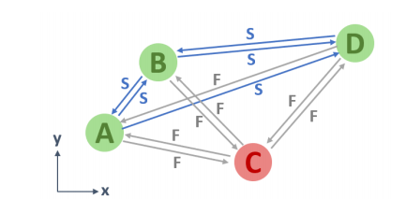

K8 is the signal broadcasted from D. We could see there is an ‘F’ on the gray line pointing from D to A. Which means A could not see D, and direction of such line is from D to A .

However in section 5, I’m confused by the deduction:

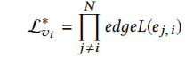we are going to use this formula to calculate L*vi respectively.

Here e_j,i infers Vj can see Vi. We know from the previous graph that the arrow direction means “being seen by someone”.

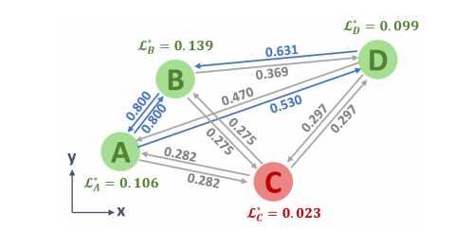

Therefore, if we want to calculate L*v value of node A, we should take 0.800, 0.530, and 0.282 as the parameter, which are outgoing lines of node A.

However, according to the paper, we should take incoming lines instead of outgoing ones.

This makes me confused.